Lexicographically Maximum Subsequence
http://www.codeforces.com/contest/197/problem/C

You are given a string s consisting of only lowercase letters. You need to find its lexicographically maximum subsequence. For more details please check the problem statement.

The strategy to solve this problem is greedy. Let's first consider the following sample case abbcbccacbbcbaaba where the answer is cccccbba. If we construct an adjacency list with the positions where each letter appear we got the following:

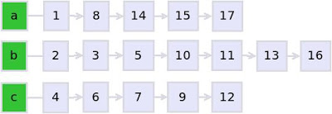

We start from the letter with the highest lexicographical value and add all the members of the list to our string. In the second step the greedy algorithm follow the same strategy, pick the next letter with the highest lexicographical value but with one exception; we can not pick letters that precede the ones that are already in our string. To deal with this issue we just takes the ones that has greater position that the last letter pick from the previous step. After applied this strategy we end selecting the letters on the positions inside the red rectangles that is the desire lexicographically maximum subsequence:

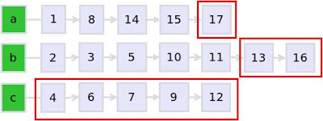

#include<bits/stdc++.h>
using namespace std;
vector<int> a[26];
int main()
{
string s, res = "";
cin >> s;
for(int i=0; i<s.size(); ++i)
a[s[i]-'a'].push_back(i);

int ind = -1;
for(int i=25; i>=0; --i)
{
for(int j=0; j<a[i].size(); ++j)
{
if(a[i][j]>ind)
res+=(char)('a'+i);

ind = max(ind, a[i][j]);
}
}

cout << res << endl;

return 0;
}

UVA 11076 - Add Again
http://uva.onlinejudge.org/external/110/11076.html
You are given an sequence of n(1⩽n⩽12) digits, your task is to return the summation of all the unique permutations of those digits.
For example given the digits 1,2,3 the sum of all the permutations is 1332:
123+213+132+231+312+321=1332
The first question we should ask ourselves, it's possible to solve this problem using the brute force approach under the 3 seconds time limit constraint? The answer is no, the reason is simple, we are given at most 12 digits and 20,000 test cases. In the worst case scenario we have 20,000 have 20,000*12!=9,580,032,000,000, that is a pretty big number.
To simplify things a little bit I am going to divide the solution in the following two cases:
(1) All the digits in the sequence are unique.
A really important observation is that all the digits appear the same number of time for any position. Let's consider the initial example where the digits are 1,2,3:
All the permutations gave us the following set:
{123,213,132,231,312,321}
If we put attention we can see that all the digits appear the same number of times (2 times) in each of the positions hundreds, tens and ones. The following example mark with red the hundreds positions:
{123,132},{213,231},{312,321}
Another important detail to notice is once you fixed some arbitrary digit in certain position (e.g. ones, tens, hundreds, ...), the number of times that digit is going to occupied that position is (n−1)!, where n is the length of the target sequence. Now let's denote S_{Ak} as the sum of all the positions that the A_{k} digit can occupied in all the unique permutations of the sequence, for each of the digits we got the following:
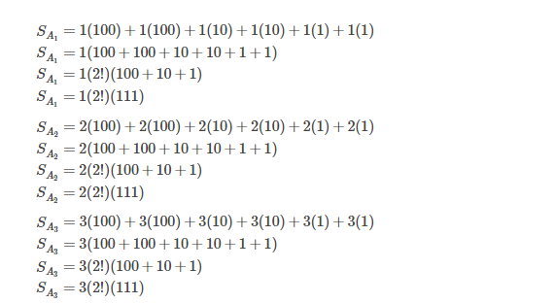

To get our result we just need to add up the partials sum of each element in the sequence:
S = S_{A1}+S_{A2}+S_{A3}=1332
Generalizing the results obtained in the previous steps we have:
S_{Ak} = A_{k*}((n−1)!)*((10^{n}−1)/9)
S = S_{A1}+S_{A2}+...+S_{An}

Do not get confused by the formula (10^{n}−1)/9 this formula gave us the elements in the sequence {0,1,11,111,...}.
(2) There is one or more digits repeated in the sequence.
The only difference between this case and the previous one is that now we need to eliminate the repetitions. Let's denote f(A_{k}) as the frequency of the digit A_{k} in the sequence A. We got the following expression:
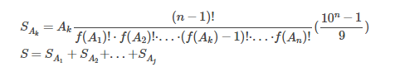
Notice that because we can have repetitions the total sum S, is restricted just to the unique elements of the sequence A, this is why we introduce a variable j where 1⩽j⩽n. We can also observe that the cases where each digit appear only one time, all the frequencies are going to gave us a product of 1, this means that the first formula is just one special case of the second one, knowing this we can forget about the first one and generalize both cases with the current formula.
If we implement the ideas set out above we are going to end up with an algorithm with overall time complexity of O(n).

Solution:
#include<bits/stdc++.h>
using namespace std;
typedef unsigned long long ull;

ull fact[15],p[15];
int n, A[15], freq[15], vis[15];

int main()
{
fact[0]=1;
for(int i=1; i<=12; i++) fact[i]=fact[i-1]*i;
p[0]=0;
for(int i=1; i<=12; i++) p[i]=(p[i-1]*10)+1;

while(scanf("%d",&n)&&n)
{
memset(vis, 0, sizeof(vis));
memset(freq, 0, sizeof(freq));

for(int i=0; i<n; ++i)
{
scanf("%d",&A[i]);
freq[A[i]]++;
}

ull sum = 0LL;
for(int i = 0; i < n; ++i)
{
if(vis[A[i]]) continue;

vis[A[i]] = 1;
ull f = fact[n-1];

for(int j=0; j<=9; ++j)
{
int ind = freq[j] - (A[i]==j);
f /= fact[ind];
}
sum += f * p[n] * A[i];
}
printf("%llu\n",sum);
}
return 0;
}

UVA 11654 - Arithmetic Subsequence
http://uva.onlinejudge.org/external/116/11654.html
You are given a set of given a set of integers, determine how many proper subsets of this set form an arithmetic sequence.
For those that forgot what is an arithmetic sequence (or arithmetic progression), is a sequence such that the difference between successive elements is constant. For example, {2,4,8,10} is an arithmetic sequence where the constant different of each element is two.
It is always a good idea to verify if the brute force solution (if any) runs under the time limit. The idea behind the brute force approach is to generated all possible subsequence of the given set, and check whether or not is an arithmetic sequence. Is not hard to see, that the constraints are way to high for this solution, N can reach up to 250, which means that we can have 2250 subsets, in other words not possible under the 5 seconds time constraint.
To solve this problem we need to do reduced from exponential time complexity to linear, this is when Dynamic Programming comes into play.
First let's make some observations about the arithmetic sequences. It is always possible to create all the size one and two subsequences for any given set. This means, the answer is always at least (N+N(N−1))/2. Knowing this, the idea behind the DP solution is to first pick some sequence of two elements which ends points are the index i and j. After we do this, we tried to extend this subsequence checking if there is any subsequence ending at index k that we can connect with our current one. In order to be able to connect a subsequence with another one the difference between their successive elements must be equal, as the definition of arithmetic sequence establish.
The overall time complexity of this solution is O(N³).

#include<bits/stdc++.h>
using namespace std;
const int MOD = 10000007;
int DP[256][256], A[256];
int main()
{
int TC, res;
scanf("%d",&TC);
for(int tc = 1; tc <= TC; ++tc)
{
int N;
scanf("%d",&N);
for(int i=0; i<N; ++i) scanf("%d",&A[i]);
res = N;

memset(DP, 0, sizeof(DP));
for(int i=1; i<N; ++i)
{
for(int j=i-1; j>=0; --j)
{
int diff = A[i]-A[j];
DP[i][j] = 1;
for(int k=j-1; k>=0; --k)
{
int diff2 = A[j]-A[k];
if(diff==diff2) DP[i][j] += DP[j][k];
if(DP[i][j]>=MOD) DP[i][j] -= MOD;
}
res += DP[i][j];
if(res>=MOD) res -= MOD;
}
}
printf("Case %d: %d\n",tc, res);
}
return 0;
}

Limit
http://www.codeforces.com/contest/197/problem/B

You are given two polynomials of the form:
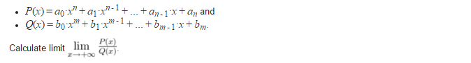
This problem looks like a pre-calculus exercise to me. I think for further contest authors should avoid this kind of task. The reason why is because give some advantage to people that are more familiar with this concepts. The easier way to came out with a solution is getting your hands dirty and solve some of the sample cases.
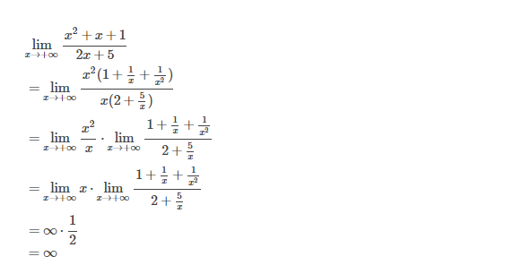
As we can see from the previous example the term with maximum exponent for each polynomial (or the degree of the polynomial) determine the value of the limit. From this fact we can generalize three possible cases:
1) n is equal to m:
In this case the x get cancel from P(x) and Q(x) and the answer become a fraction formed by the coefficients of the highest degree term of each equation. Because, the problem ask you to return a irreducible fraction we divide each coefficient a and b by the gcd(a,b).
2) n is greater than m
This case is the same as the previous example, the answer can be +∞ or -∞ depending if for each polynomial the product of the term with highest degree is positive or negative.
3) n is less than m

In this case the answer is always 0

Solution:

#include<bits/stdc++.h>
using namespace std;
int P[128], Q[128];
int main()
{
int n,m;
scanf("%d%d",&n,&m);
for(int i=0; i<=n; ++i) scanf("%d",&P[i]);
for(int i=0; i<=m; ++i) scanf("%d",&Q[i]);

if(n==m)
{
int d = __gcd(P[0], Q[0]);
if(P[0]*Q[0] < 0) printf("-");
printf("%d/%d\n",abs(P[0]/d), abs(Q[0]/d));
}
else if(n>m)
{
if(P[0]*Q[0] < 0) printf("-");
printf("Infinity\n");
}
else
printf("0/1\n");

return 0;
}

UVA 10910 - Marks Distribution
http://uva.onlinejudge.org/external/109/10910.html
a student has taken a total of N subjects. To pass a certain subject, he need a least P marks of grade. He got total T marks among all your examinations. Your task is to print how many different ways he can distributed those marks among the N subjects in such way he pass all of them.
This problem can be solve with Dynamic Programming. The first thing to note is that we don't need to bother with distributions of grades were one or more grades are less than P. In other words, we can assume that all the subjects start with P marks. Knowing this we just need to care in how to distribute the remaining T−N⋅P marks left.
The state of the DP state is simple: (current subject, remaining marks) = total number of configurations. For each subject recursively we tried all the possible assignments of marks. Because we are counting different configurations the base case return the number 1. We use the variable res to add up all the valid configurations founded by the recursion function.
Solution:
typedef long long ll;
ll dp[102][102];
ll fun(ll cur, ll rem)
{
if(cur==1 || rem==0LL) return 1LL;
if(dp[cur][rem] != -1) return dp[cur][rem];
ll res=0;
for(int i=0; i<=rem; ++i) res+=fun(cur-1, rem-i);
return dp[cur][rem] = res;
}
int main()
{
int TC; scanf("%d",&TC);
while(TC--)
{
ll N,T,P; scanf("%lld%lld%lld",&N,&T,&P);
memset(dp, -1, sizeof(dp));
ll ans = fun(N, T-(N*P));
printf("%lld\n",ans);
}
}

